Network load balancer

Network load balancer is similar to application load balancer

We can attach elastic ips to network load balancer

Scale millon requests per second

It is a layer4 load balancing

It is for tcp traffic routes

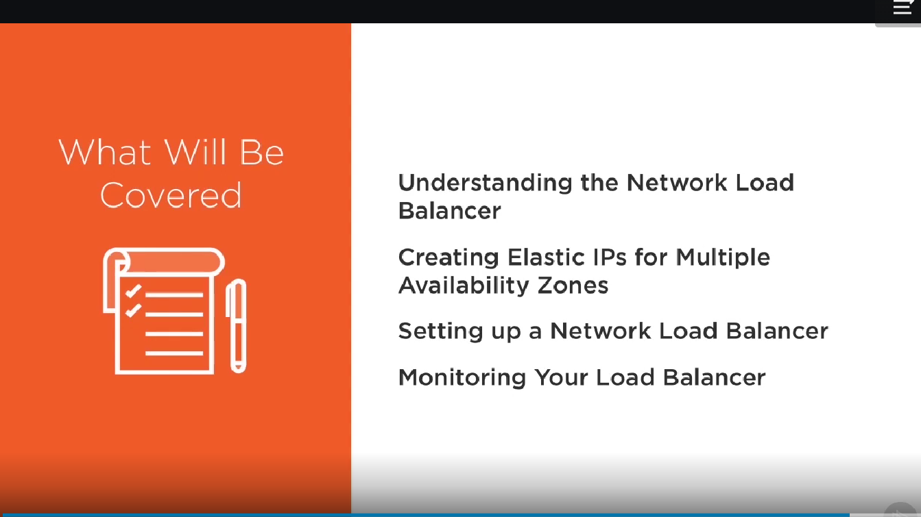

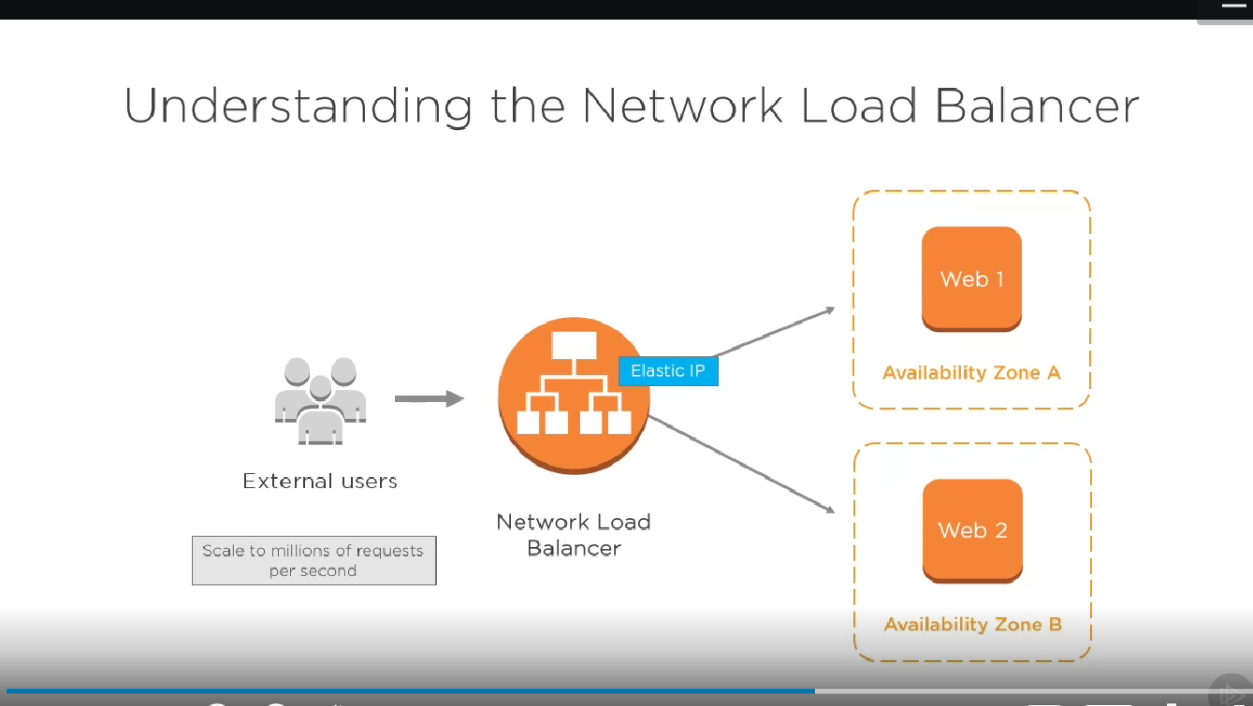

Creating elastic ips to different availability zones.

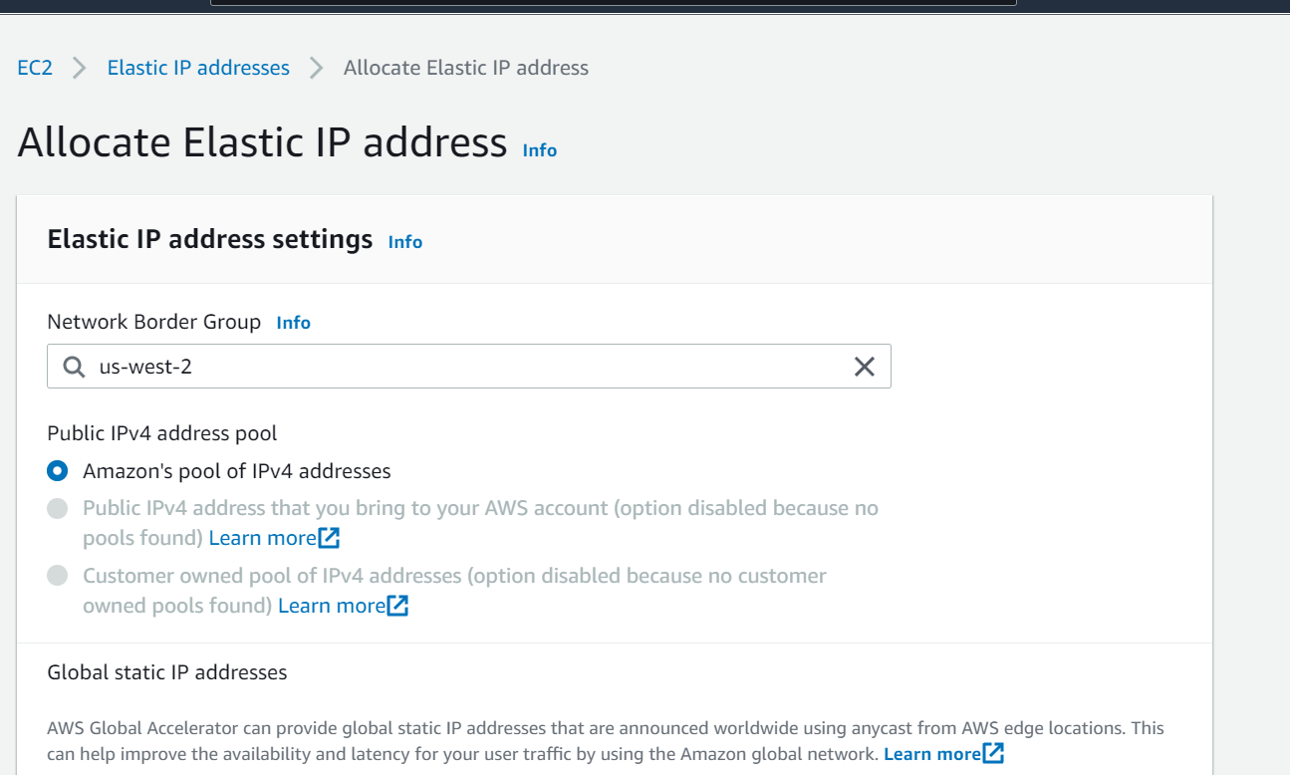

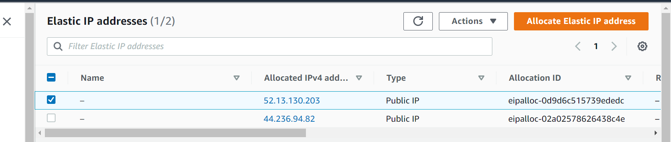

Creating load balancer

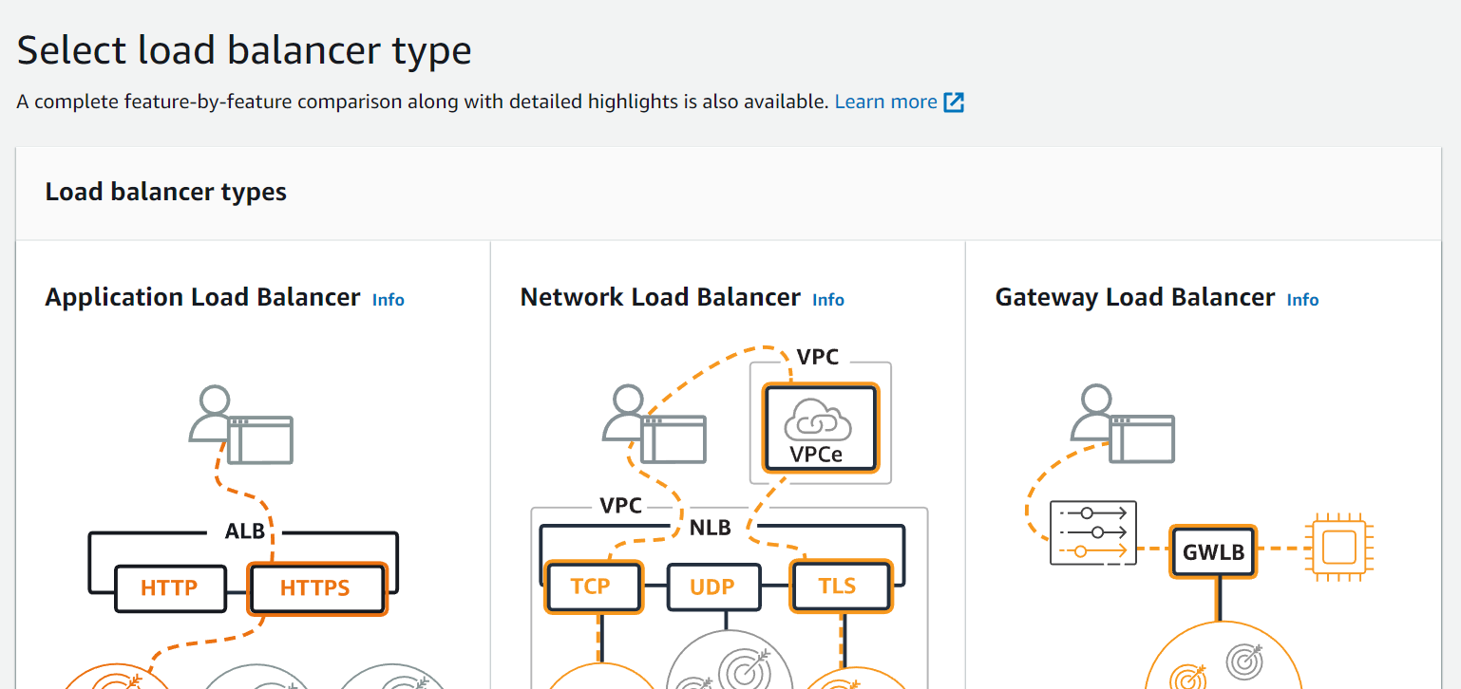

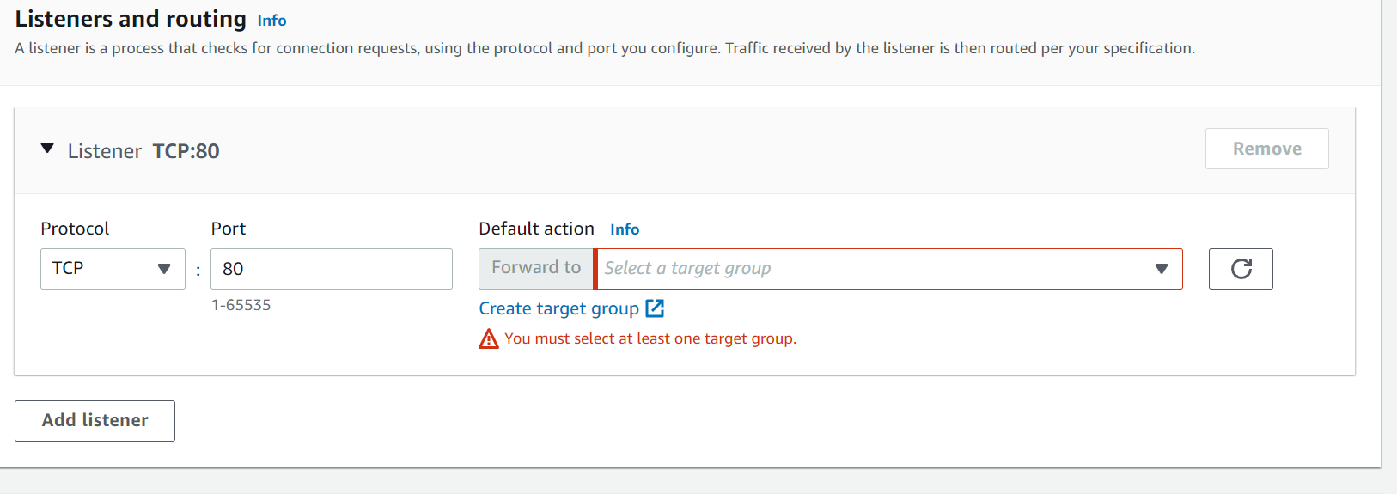

Network load balancer has been created

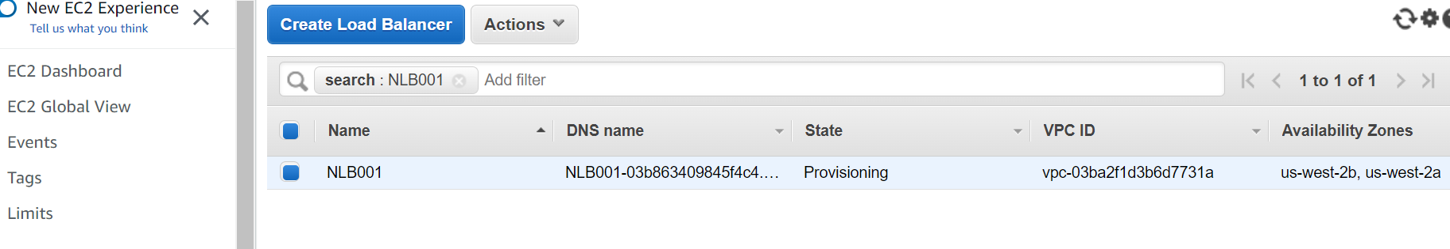

Monitoring enable in network load balancer

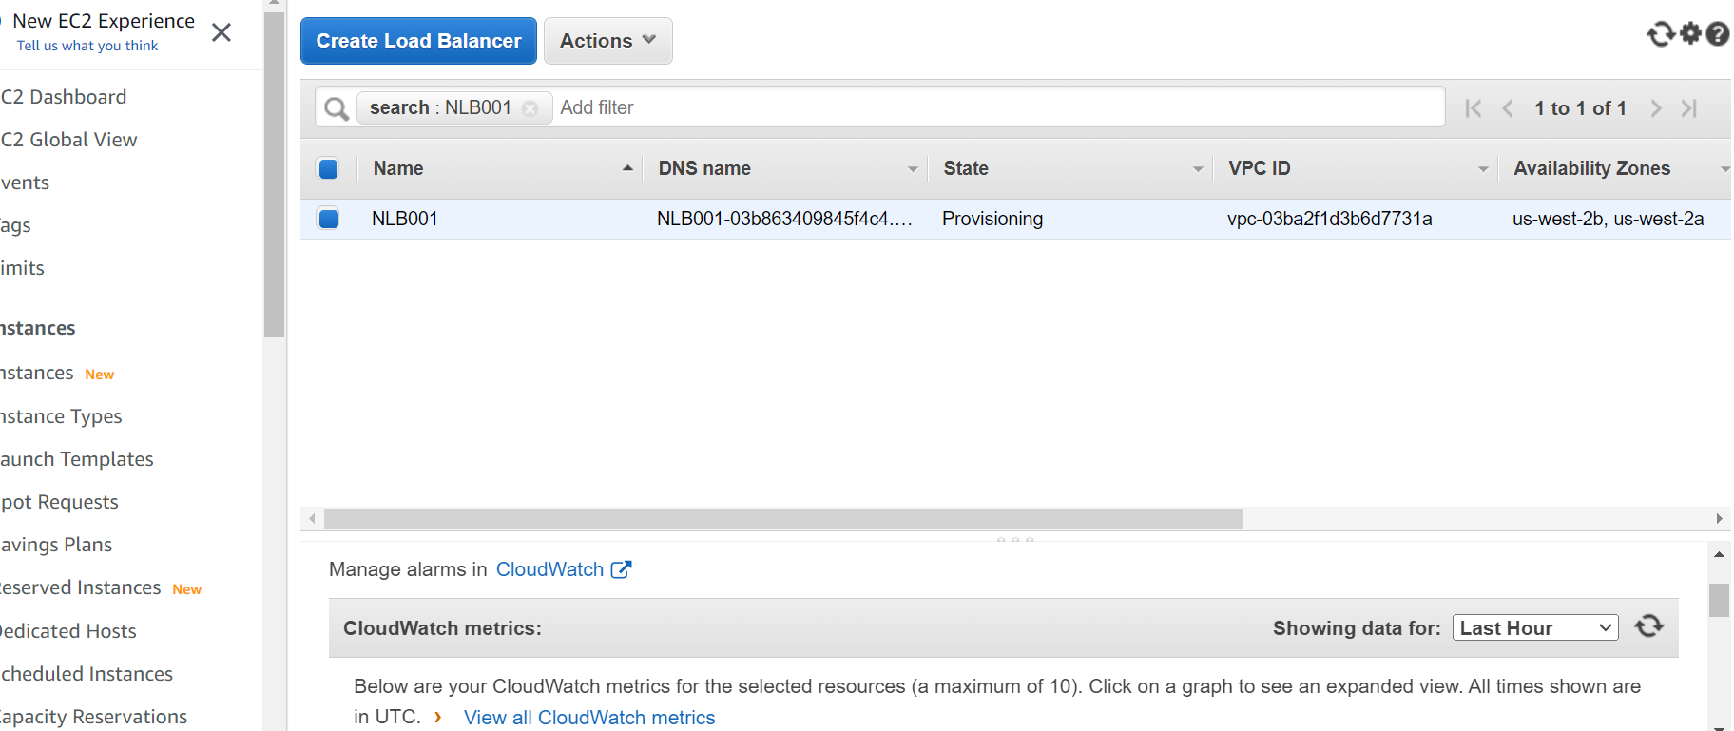

Manage alarms in cloud watch

